**Controlling LED using Bluetooth Module**

**Description**: In this project , we will control the led using Bluetooth Module HC-05.

**HC-05 Bluetooth Module:**

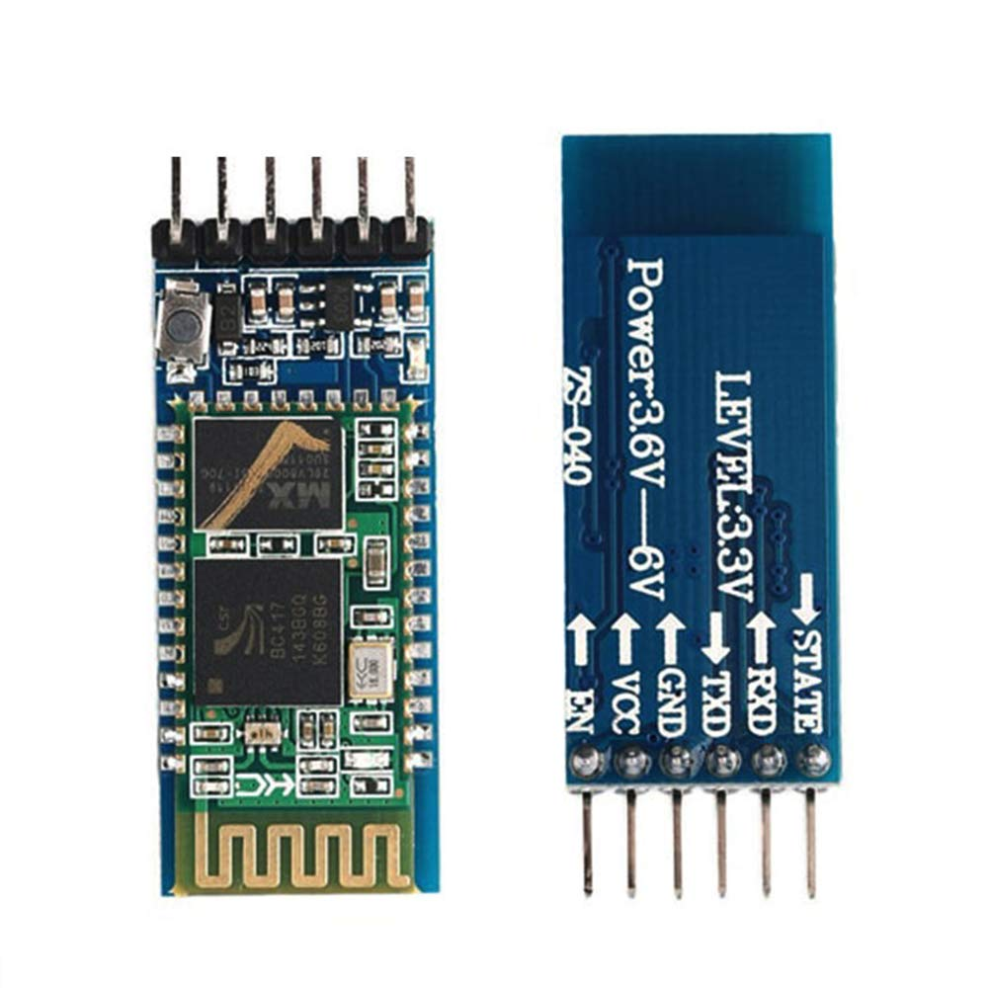

Connection:

* HC-05 ‘s VCC pin connected to arduino’s 5/3.3v(5v better)
* HC-05’s GND pin connected to ground
* HC-05’s TXD pin connected to arduino’s RX pin (pin-0)
* HC_05’s RXD pin connected to Arduino’s TX pin(pin-1)

Code:

|  |  |
| --- | --- |
| char s;  //state int p1=2; //pin1 int p2=7; //pin2 void setup() {   // put your setup code here, to run once:   pinMode(p1,OUTPUT); pinMode(p2,OUTPUT); Serial.begin(9600); }   void loop() {   // put your main code here, to run repeatedly: if(Serial.available()!=0) {   s=Serial.read(); }   if(s=='1') { digitalWrite(p1,HIGH);  } if(s=='2') { digitalWrite(p1,LOW);  } if(s=='3') { digitalWrite(p2,HIGH);  } if(s=='4') { digitalWrite(p2,LOW);  } } |  |

Circuit Diagram:

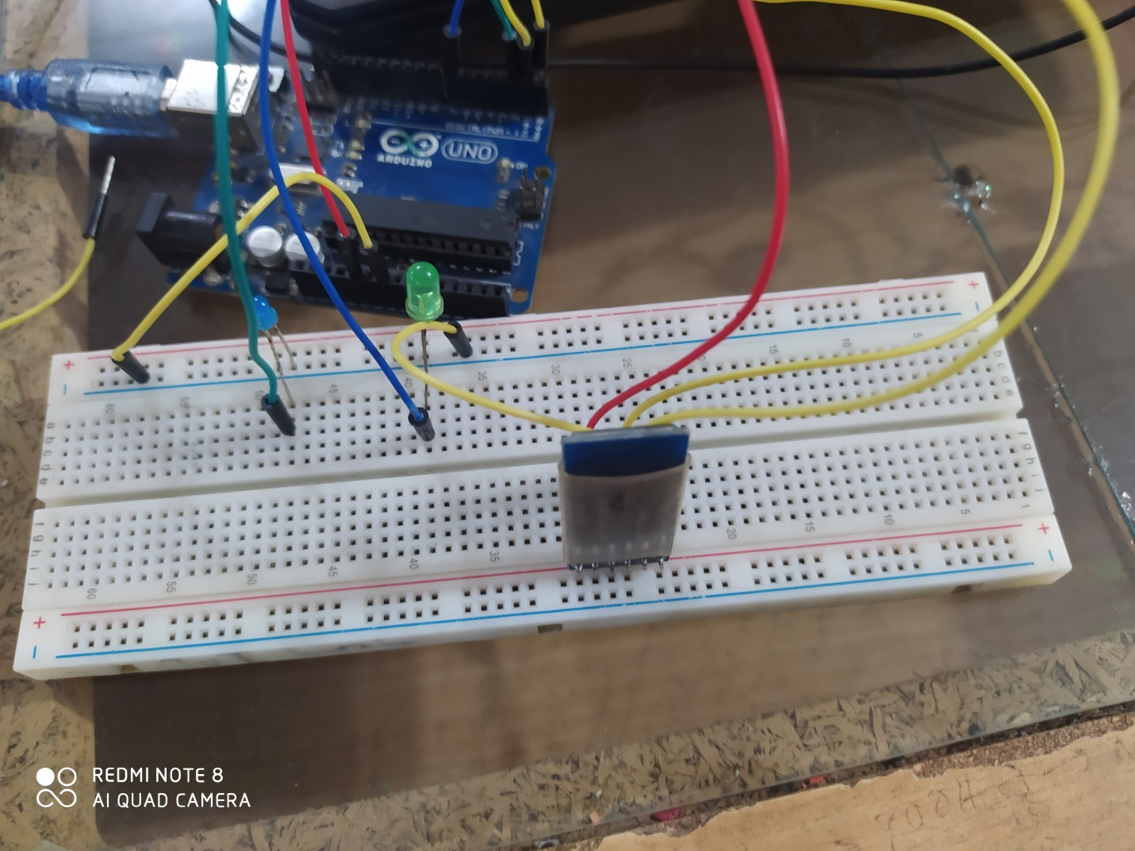

**Controlling:**

1st  Install the Bluetooth Terminal On Our phone

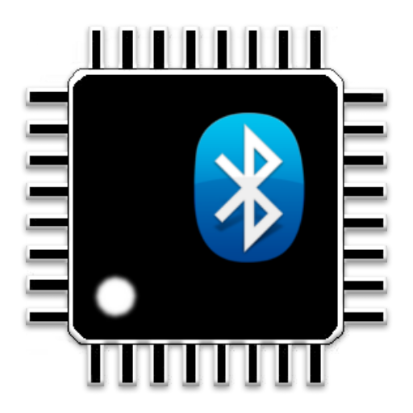

Then on Bluetooth on our phone and connected to HC-05

And then ON the Bluetooth Terminal app

And connted to HC-05

VEDIO LINK :<https://www.youtube.com/watch?v=I67N_cJM1aE&list=PL7euiE97qGc0QbibUmHn5MBrF2V7w3NDa&index=19>